**Process Concept**

A question that arises in discussing operating systems involves what to call all the CPU activities. A batch system executes jobs, whereas a time-shared system has user programs, or tasks. Even on a single-user system, a user may be able to run several programs at one time: a word processor, a Web browser, and an e-mail package. And even if a user can execute only one program at a time, such as on an embedded device that does not support multitasking, the operating system may need to support its own internal programmed activities, such as memory management. In many respects, all these activities are similar, so we call all of them processes.

The terms job and process are used almost interchangeably in this text. Although we personally prefer the term process, much of operating-system theory and terminology was developed during a time when the major activity of operating systems was job processing. It would be misleading to avoid the use of commonly accepted terms that include the word job (such as job scheduling) simply because process has superseded job.

**The Process**

Informally, as mentioned earlier, a process is a program in execution. A process is more than the program code, which is sometimes known as the text section. It also includes the current activity, as represented by the value of the program counter and the contents of the processor’s registers. A process generally also includes the process stack, which contains temporary data (such as function parameters, return addresses, and local variables), and a data section, which contains global variables. A process may also include a heap, which is memory that is dynamically allocated during process run time. The structure of a process in memory is shown in Figure 1.20.

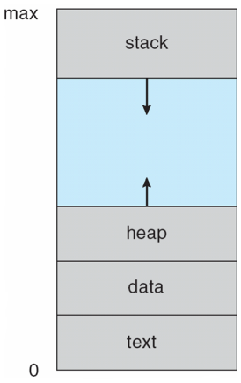

Figure 1.20 Process in memory.

We emphasize that a program by itself is not a process. A program is a passive entity, such as a file containing a list of instructions stored on disk (often called an executable file). In contrast, a process is an active entity, with a program counter specifying the next instruction to execute and a set of associated resources. A program becomes a process when an executable file is loaded into memory. Two common techniques for loading executable files are double-clicking an icon representing the executable file and entering the name of the executable file on the command line (as in prog.exe or a.out).

Although two processes may be associated with the same program, they are nevertheless considered two separate execution sequences. For instance, several users may be running different copies of the mail program, or the same user may invoke many copies of the web browser program. Each of these is a separate process; and although the text sections are equivalent, the data, heap, and stack sections vary. It is also common to have a process that spawns many processes as it runs.

Note that a process itself can be an execution environment for other code. The Java programming environment provides a good example. In most circumstances, an executable Java program is executed within the Java virtual machine (JVM). The JVM executes as a process that interprets the loaded Java code and takes actions (via native machine instructions) on behalf of that code. For example, to run the compiled Java program Program.class, we would enter

java Program

The command java runs the JVM as an ordinary process, which in turns executes the Java program Program in the virtual machine. The concept is the same as simulation, except that the code, instead of being written for a different instruction set, is written in the Java language.

**Process State**

As a process executes, it changes state. The state of a process is defined in part by the current activity of that process. A process may be in one of the following states:

**• New.** The process is being created.

**• Running.** Instructions are being executed.

**• Waiting.** The process is waiting for some event to occur (such as an I/O completion or reception of a signal).

**• Ready.** The process is waiting to be assigned to a processor.

**• Terminated.** The process has finished execution.

These names are arbitrary, and they vary across operating systems. The states that they represent are found on all systems, however. Certain operating systems also more finely delineate process states. It is important to realize that only one process can be running on any processor at any instant. Many processes may be ready and waiting, however. The state diagram corresponding to these states is presented in Figure 1.21.

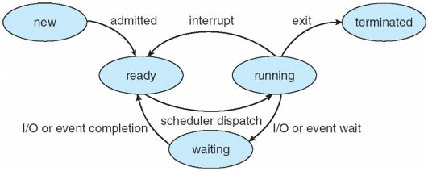

Figure 1.21 Diagram of process state.

**Process Control Block (PCB)**

Each process is represented in the operating system by a process control block (PCB)—also called a task control block. A PCB is shown in Figure 1.22. It contains many pieces of information associated with a specific process, including these:

**• Process state.** The state may be new, ready, running, waiting, halted, and so on.

**• Program counter**. The counter indicates the address of the next instruction to be executed for this process.

**• CPU registers.** The registers vary in number and type, depending on the computer architecture. They include accumulators, index registers, stack pointers, and general-purpose registers, plus any condition-code information. Along with the program counter, this state information must be saved when an interrupt occurs, to allow the process to be continued correctly afterward (Figure 3.4).

• **CPU-scheduling information.** This information includes a process priority, pointers to scheduling queues, and any other scheduling parameters.

• **Memory-management information**. This information may include such items as the value of the base and limit registers and the page tables, or the segment tables, depending on the memory system used by the operating system

**• Accounting information**. This information includes the amount of CPU and real time used, time limits, account numbers, job or process numbers, and so on.

**• I/O status information**. This information includes the list of I/O devices allocated to the process, a list of open files, and so on.

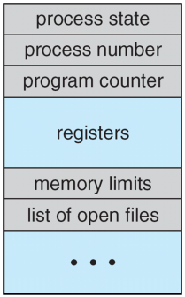

Figure 1.22 Process control block (PCB).

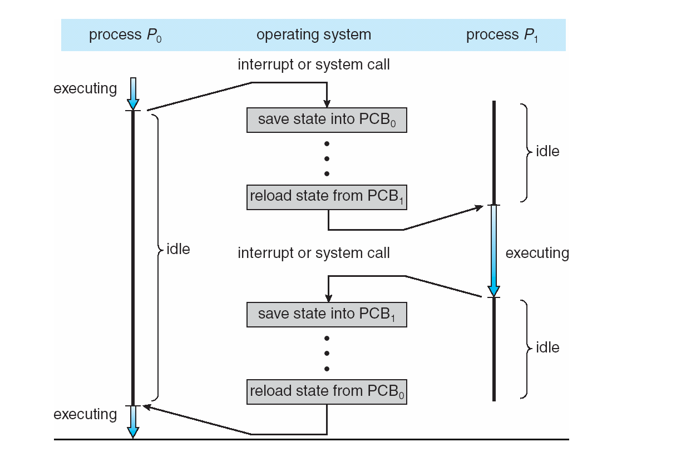

Figure 1.23 Diagram showing CPU switch from process to process.

In brief, the PCB simply serves as the repository for any information that may vary from process to process.

**Threads**

The process model discussed so far has implied that a process is a program that performs a single thread of execution. For example, when a process is running a word-processor program, a single thread of instructions is being executed. This single thread of control allows the process to perform only one task at a time. The user cannot simultaneously type in characters and run the spell checker within the same process, for example. Most modern operating systems have extended the process concept to allow a process to have multiple threads of execution and thus to perform more than one task at a time. This feature is especially beneficial on multicore systems, where multiple threads can run in parallel. On a system that supports threads, the PCB is expanded to include information for each thread. Other changes throughout the system are also needed to support threads.

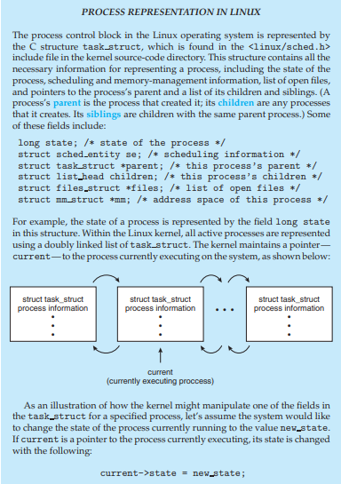

**Process Scheduling**

The objective of multiprogramming is to have some process running at all times, to maximize CPU utilization. The objective of time sharing is to switch the CPU among processes so frequently that users can interact with each program while it is running. To meet these objectives, the process scheduler selects an available process (possibly from a set of several available processes) for program execution on the CPU. For a single-processor system, there will never be more than one running process. If there are more processes, the rest will have to wait until the CPU is free and can be rescheduled.

**Scheduling Queues**

As processes enter the system, they are put into a job queue, which consists of all processes in the system. The processes that are residing in main memory and are ready and waiting to execute are kept on a list called the ready queue. This queue is generally stored as a linked list. A ready-queue header contains pointers to the first and final PCBs in the list. Each PCB includes a pointer field that points to the next PCB in the ready queue.

The system also includes other queues. When a process is allocated the CPU, it executes for a while and eventually quits, is interrupted, or waits for the occurrence of a particular event, such as the completion of an I/O request. Suppose the process makes an I/O request to a shared device, such as a disk. Since there are many processes in the system, the disk may be busy with the I/O request of some other process. The process therefore may have to wait for the disk. The list of processes waiting for a particular I/O device is called a device queue. Each device has its own device queue (Figure 1.24).

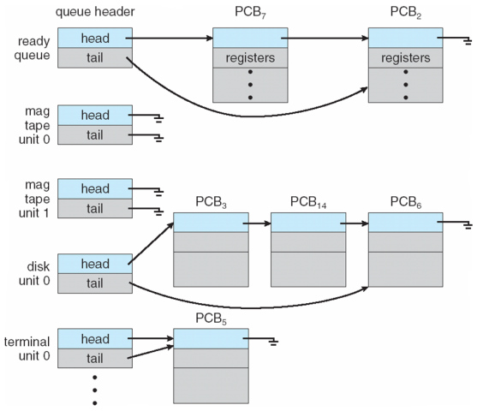

Figure 1.24 The ready queue and various I/O device queues.

A common representation of process scheduling is a queueing diagram, such as that in Figure 1.25. Each rectangular box represents a queue. Two types of queues are present: the ready queue and a set of device queues. The circles represent the resources that serve the queues, and the arrows indicate the flow of processes in the system.

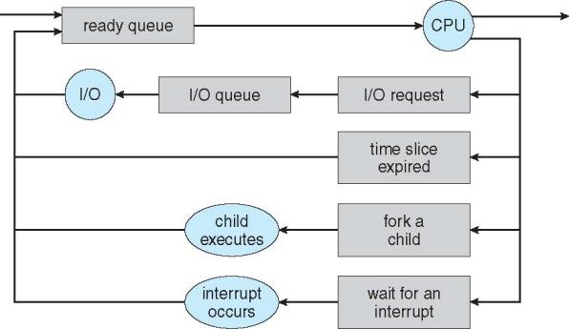

Figure 1.25 Queueing-diagram representation of process scheduling.

A new process is initially put in the ready queue. It waits there until it is selected for execution, or dispatched. Once the process is allocated the CPU and is executing, one of several events could occur:

* The process could issue an I/O request and then be placed in an I/O queue.

• The process could create a new child process and wait for the child’s termination.

• The process could be removed forcibly from the CPU, as a result of an interrupt, and be put back in the ready queue.

In the first two cases, the process eventually switches from the waiting state to the ready state and is then put back in the ready queue. A process continues this cycle until it terminates, at which time it is removed from all queues and has its PCB and resources deallocated.

**Schedulers**

A process migrates among the various scheduling queues throughout its lifetime. The operating system must select, for scheduling purposes, processes from these queues in some fashion. The selection process is carried out by the appropriate scheduler.

Often, in a batch system, more processes are submitted than can be executed immediately. These processes are spooled to a mass-storage device (typically a disk), where they are kept for later execution. The long-term scheduler, or job scheduler, selects processes from this pool and loads them into memory for execution. The short-term scheduler, or CPU scheduler, selects from among the processes that are ready to execute and allocates the CPU to one of them.

The primary distinction between these two schedulers lies in frequency of execution. The short-term scheduler must select a new process for the CPU frequently. A process may execute for only a few milliseconds before waiting for an I/O request. Often, the short-term scheduler executes at least once every 100 milliseconds. Because of the short time between executions, the short-term scheduler must be fast. If it takes 10 milliseconds to decide to execute a process for 100 milliseconds, then 10/(100 + 10) = 9 percent of the CPU is being used (wasted) simply for scheduling the work.

The long-term scheduler executes much less frequently; minutes may separate the creation of one new process and the next. The long-term scheduler controls the degree of multiprogramming (the number of processes in memory). If the degree of multiprogramming is stable, then the average rate of process creation must be equal to the average departure rate of processes leaving the system. Thus, the long-term scheduler may need to be invoked only when a process leaves the system. Because of the longer interval between executions, the long-term scheduler can afford to take more time to decide which process should be selected for execution.

It is important that the long-term scheduler make a careful selection. In general, most processes can be described as either I/O bound or CPU bound. An I/O-bound process is one that spends more of its time doing I/O than it spends doing computations. A CPU-bound process, in contrast, generates I/O requests infrequently, using more of its time doing computations. It is important that the long-term scheduler select a good process mix of I/O-bound and CPU-bound processes. If all processes are I/O bound, the ready queue will almost always be empty, and the short-term scheduler will have little to do. If all processes are CPU bound, the I/O waiting queue will almost always be empty, devices will go unused, and again the system will be unbalanced. The system with the best performance will thus have a combination of CPU-bound and I/O-bound processes.

On some systems, the long-term scheduler may be absent or minimal. For example, time-sharing systems such as UNIX and Microsoft Windows systems often have no long-term scheduler but simply put every new process in memory for the short-term scheduler. The stability of these systems depends either on a physical limitation (such as the number of available terminals) or on the self-adjusting nature of human users. If performance declines to unacceptable levels on a multiuser system, some users will simply quit.

**Multitasking in Mobile Systems**

Because of the constraints imposed on mobile devices, early versions of iOS did not provide user-application multitasking; only one application runs in the foreground and all other user applications are suspended. Operatingsystem tasks were multitasked because they were written by Apple and well behaved. However, beginning with iOS 4, Apple now provides a limited form of multitasking for user applications, thus allowing a single foreground application to run concurrently with multiple background applications. (On a mobile device, the foreground application is the application currently open and appearing on the display. The background application remains in memory, but does not occupy the display screen.) The iOS 4 programming API provides support for multitasking, thus allowing a process to run in the background without being suspended. However, it is limited and only available for a limited number of application types, including applications

• running a single, finite-length task (such as completing a download of content from a network);

• receiving notifications of an event occurring (such as a new email message);

• with long-running background tasks (such as an audio player.)

Apple probably limits multitasking due to battery life and memory use concerns. The CPU certainly has the features to support multitasking, but Apple chooses to not take advantage of some of them in order to better manage resource use.

Android does not place such constraints on the types of applications that can run in the background. If an application requires processing while in the background, the application must use a service, a separate application component that runs on behalf of the background process. Consider a streaming audio application: if the application moves to the background, the service continues to send audio files to the audio device driver on behalf of the background application. In fact, the service will continue to run even if the background application is suspended. Services do not have a user interface and have a small memory footprint, thus providing an efficient technique for multitasking in a mobile environment.

**Context Switch**

Interrupts cause the operating system to change a CPU from its current task and to run a kernel routine. Such operations happen frequently on general-purpose systems. When an interrupt occurs, the system needs to save the current context of the process running on the CPU so that it can restore that context when its processing is done, essentially suspending the process and then resuming it. The context is represented in the PCB of the process. It includes the value of the CPU registers, the process state (see Figure 1.21), and memory-management information. Generically, we perform a state save of the current state of the CPU, be it in kernel or user mode, and then a state restore to resume operations.

Switching the CPU to another process requires performing a state save of the current process and a state restore of a different process. This task is known as a context switch. When a context switch occurs, the kernel saves the context of the old process in its PCB and loads the saved context of the new process scheduled to run. Context-switch time is pure overhead, because the system does no useful work while switching. Switching speed varies from machine to machine, depending on the memory speed, the number of registers that must be copied, and the existence of special instructions (such as a single instruction to load or store all registers). A typical speed is a few milliseconds.

Context-switch times are highly dependent on hardware support. For instance, some processors (such as the Sun UltraSPARC) provide multiple sets of registers. A context switch here simply requires changing the pointer to the current register set. Of course, if there are more active processes than there are register sets, the system resorts to copying register data to and from memory, as before. Also, the more complex the operating system, the greater the amount of work that must be done during a context switch. Advanced memory-management techniques may require that extra data be switched with each context. For instance, the address space of the current process must be preserved as the space of the next task is prepared for use. How the address space is preserved, and what amount of work is needed to preserve it, depend on the memory-management method of the operating system.

**Operations on Processes**

The processes in most systems can execute concurrently, and they may be created and deleted dynamically. Thus, these systems must provide a mechanism for process creation and termination. In this section, we explore the mechanisms involved in creating processes and illustrate process creation on UNIX and Windows systems.

**Process Creation**

During the course of execution, a process may create several new processes. As mentioned earlier, the creating process is called a parent process, and the new processes are called the children of that process. Each of these new processes may in turn create other processes, forming a tree of processes.

Most operating systems (including UNIX, Linux, and Windows) identify processes according to a unique process identifier (or pid), which is typically an integer number. The pid provides a unique value for each process in the system, and it can be used as an index to access various attributes of a process within the kernel.

Figure 1.26 illustrates a typical process tree for the Linux operating system, showing the name of each process and its pid. (We use the term process rather loosely, as Linux prefers the term task instead.) The init process (which always has a pid of 1) serves as the root parent process for all user processes. Once the system has booted, the init process can also create various user processes, such as a web or print server, an ssh server, and the like. In Figure 1.26, we see two children of init—kthreadd and sshd. The kthreadd process is responsible for creating additional processes that perform tasks on behalf of the kernel (in this situation, khelper and pdflush). The sshd process is responsible for managing clients that connect to the system by using ssh (which is short for secure shell). The login process is responsible for managing clients that directly log onto the system. In this example, a client has logged on and is using the bash shell, which has been assigned pid 8416. Using the bash command-line interface, this user has created the process ps as well as the emacs editor.

On UNIX and Linux systems, we can obtain a listing of processes by using the ps command. For example, the command

ps –el

will list complete information for all processes currently active in the system. It is easy to construct a process tree similar to the one shown in Figure 1,26 by recursively tracing parent processes all the way to the init process.

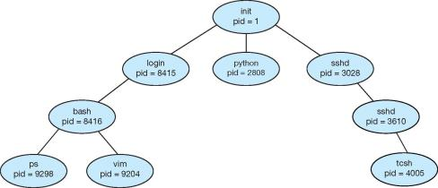

Figure 1.26 A tree of processes on a typical Linux system.

In general, when a process creates a child process, that child process will need certain resources (CPU time, memory, files, I/O devices) to accomplish its task. A child process may be able to obtain its resources directly from the operating system, or it may be constrained to a subset of the resources of the parent process. The parent may have to partition its resources among its children, or it may be able to share some resources (such as memory or files) among several of its children. Restricting a child process to a subset of the parent’s resources prevents any process from overloading the system by creating too many child processes.

In addition to supplying various physical and logical resources, the parent process may pass along initialization data (input) to the child process. For example, consider a process whose function is to display the contents of a file —say, image.jpg—on the screen of a terminal. When the process is created, it will get, as an input from its parent process, the name of the file image.jpg. Using that file name, it will open the file and write the contents out. It may also get the name of the output device. Alternatively, some operating systems pass resources to child processes. On such a system, the new process may get two open files, image.jpg and the terminal device, and may simply transfer the datum between the two.

When a process creates a new process, two possibilities for execution exist:

1. The parent continues to execute concurrently with its children.

2. The parent waits until some or all of its children have terminated.

There are also two address-space possibilities for the new process:

1. The child process is a duplicate of the parent process (it has the same program and data as the parent).

2. The child process has a new program loaded into it.

To illustrate these differences, let’s first consider the UNIX operating system. In UNIX, as we’ve seen, each process is identified by its process identifier, which is a unique integer. A new process is created by the fork() system call. The new process consists of a copy of the address space of the original process. This mechanism allows the parent process to communicate easily with its child process. Both processes (the parent and the child) continue execution at the instruction after the fork(), with one difference: the return code for the fork() is zero for the new (child) process, whereas the (nonzero) process identifier of the child is returned to the parent.

After a fork() system call, one of the two processes typically uses the exec() system call to replace the process’s memory space with a new program. The exec() system call loads a binary file into memory (destroying the memory image of the program containing the exec() system call) and starts its execution. In this manner, the two processes are able to communicate and then go their separate ways. The parent can then create more children; or, if it has nothing else to do while the child runs, it can issue a wait() system call to move itself off the ready queue until the termination of the child. Because the call to exec() overlays the process’s address space with a new program, the call to exec() does not return control unless an error occurs.

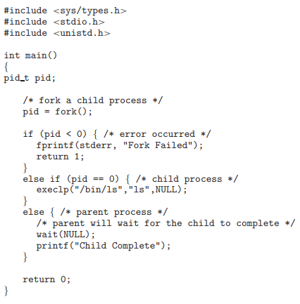

Figure 1.27 Creating a separate process using the UNIX fork() system call.

The C program shown in Figure 1.27 illustrates the UNIX system calls previously described. We now have two different processes running copies of the same program. The only difference is that the value of pid (the process identifier) for the child process is zero, while that for the parent is an integer value greater than zero (in fact, it is the actual pid of the child process). The child process inherits privileges and scheduling attributes from the parent, as well certain resources, such as open files. The child process then overlays its address space with the UNIX command /bin/ls (used to get a directory listing) using the execlp() system call (execlp() is a version of the exec() system call). The parent waits for the child process to complete with the wait() system call. When the child process completes (by either implicitly or explicitly invoking exit()), the parent process resumes from the call to wait(), where it completes using the exit() system call. This is also illustrated in Figure 1.28.

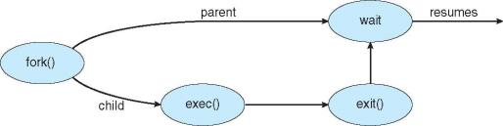

Figure 1.28 Process creation using the fork() system call

Of course, there is nothing to prevent the child from not invoking exec() and instead continuing to execute as a copy of the parent process. In this scenario, the parent and child are concurrent processes running the same code instructions. Because the child is a copy of the parent, each process has its own copy of any data.

As an alternative example, we next consider process creation in Windows. Processes are created in the Windows API using the CreateProcess() function, which is similar to fork() in that a parent creates a new child process. However, whereas fork() has the child process inheriting the address space of its parent, CreateProcess() requires loading a specified program into the address space of the child process at process creation. Furthermore, whereas fork() is passed no parameters, CreateProcess() expects no fewer than ten parameters.

The C program shown in Figure 1.29 illustrates the CreateProcess() function, which creates a child process that loads the application mspaint.exe. We opt for many of the default values of the ten parameters passed to CreateProcess(). Readers interested in pursuing the details of process creation and management in the Windows API are encouraged to consult the bibliographical notes at the end of this chapter.

The two parameters passed to the CreateProcess() function are instances of the STARTUPINFO and PROCESS INFORMATION structures. STARTUPINFO specifies many properties of the new process, such as window size and appearance and handles to standard input and output files. The PROCESS INFORMATION structure contains a handle and the identifiers to the newly created process and its thread. We invoke the ZeroMemory() function to allocate memory for each of these structures before proceeding with CreateProcess().

The first two parameters passed to CreateProcess() are the application name and command-line parameters. If the application name is NULL (as it is in this case), the command-line parameter specifies the application to load. In this instance, we are loading the Microsoft Windows mspaint.exe application. Beyond these two initial parameters, we use the default parameters for inheriting process and thread handles as well as specifying that there will be no creation flags. We also use the parent’s existing environment block and starting directory. Last, we provide two pointers to the STARTUPINFO and PROCESS - INFORMATION structures created at the beginning of the program. In Figure .27, the parent process waits for the child to complete by invoking the wait() system call. The equivalent of this in Windows is WaitForSingleObject(), which is passed a handle of the child process—pi.hProcess—and waits for this process to complete. Once the child process exits, control returns from the WaitForSingleObject() function in the parent process.

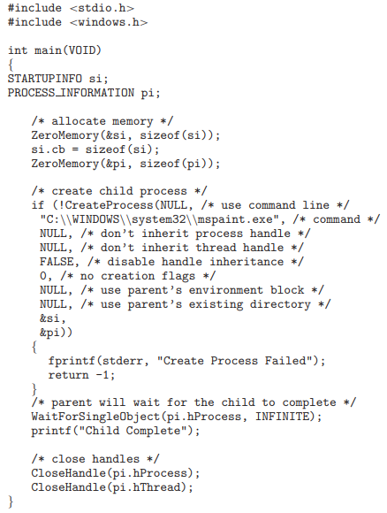

Figure 1.29 Creating a separate process using the Windows API.

**Process Termination**

A process terminates when it finishes executing its final statement and asks the operating system to delete it by using the exit() system call. At that point, the process may return a status value (typically an integer) to its parent process (via the wait() system call). All the resources of the process—including physical and virtual memory, open files, and I/O buffers—are deallocated by the operating system.

Termination can occur in other circumstances as well. A process can cause the termination of another process via an appropriate system call (for example, TerminateProcess() in Windows). Usually, such a system call can be invoked only by the parent of the process that is to be terminated. Otherwise, users could arbitrarily kill each other’s jobs. Note that a parent needs to know the identities of its children if it is to terminate them. Thus, when one process creates a new process, the identity of the newly created process is passed to the parent.

A parent may terminate the execution of one of its children for a variety of reasons, such as these:

• The child has exceeded its usage of some of the resources that it has been allocated. (To determine whether this has occurred, the parent must have a mechanism to inspect the state of its children.)

• The task assigned to the child is no longer required.

• The parent is exiting, and the operating system does not allow a child to continue if its parent terminates.

Some systems do not allow a child to exist if its parent has terminated. In such systems, if a process terminates (either normally or abnormally), then all its children must also be terminated. This phenomenon, referred to as cascading termination, is normally initiated by the operating system.

To illustrate process execution and termination, consider that, in Linux and UNIX systems, we can terminate a process by using the exit() system call, providing an exit status as a parameter:

/* exit with status 1 */

exit(1);

In fact, under normal termination, exit() may be called either directly (as shown above) or indirectly (by a return statement in main()).

A parent process may wait for the termination of a child process by using the wait() system call. The wait() system call is passed a parameter that allows the parent to obtain the exit status of the child. This system call also returns the process identifier of the terminated child so that the parent can tell which of its children has terminated:

pid t pid;

int status;

pid = wait(&status);

When a process terminates, its resources are deallocated by the operating system. However, its entry in the process table must remain there until the parent calls wait(), because the process table contains the process’s exit status. A process that has terminated, but whose parent has not yet called wait(), is known as a zombie process. All processes transition to this state when they terminate, but generally they exist as zombies only briefly. Once the parent calls wait(), the process identifier of the zombie process and its entry in the process table are released.

**Interprocess Communication**

Processes executing concurrently in the operating system may be either independent processes or cooperating processes. A process is independent if it cannot affect or be affected by the other processes executing in the system. Any process that does not share data with any other process is independent. A process is cooperating if it can affect or be affected by the other processes executing in the system. Clearly, any process that shares data with other processes is a cooperating process.

There are several reasons for providing an environment that allows process cooperation:

• **Information sharing**. Since several users may be interested in the same piece of information (for instance, a shared file), we must provide an environment to allow concurrent access to such information.

• **Computation speedup**. If we want a particular task to run faster, we must break it into subtasks, each of which will be executing in parallel with the others. Notice that such a speedup can be achieved only if the computer has multiple processing cores.

• **Modularity**. We may want to construct the system in a modular fashion, dividing the system functions into separate processes or threads.

• **Convenience**. Even an individual user may work on many tasks at the same time. For instance, a user may be editing, listening to music, and compiling in parallel.

Cooperating processes require an interprocess communication (IPC) mechanism that will allow them to exchange data and information. There are two fundamental models of interprocess communication: shared memory and message passing. In the shared-memory model, a region of memory that is shared by cooperating processes is established. Processes can then exchange information by reading and writing data to the shared region. In the message-passing model, communication takes place by means of messages exchanged between the cooperating processes. The two communications models are contrasted in Figure 1.30.

Both of the models just mentioned are common in operating systems, and many systems implement both. Message passing is useful for exchanging smaller amounts of data, because no conflicts need be avoided. Message passing is also easier to implement in a distributed system than shared memory. (Although there are systems that provide distributed shared memory, we do not consider them in this text.) Shared memory can be faster than message passing, since message-passing systems are typically implemented using system calls and thus require the more time-consuming task of kernel intervention. In shared-memory systems, system calls are required only to establish shared-memory regions. Once shared memory is established, all accesses are treated as routine memory accesses, and no assistance from the kernel is required.

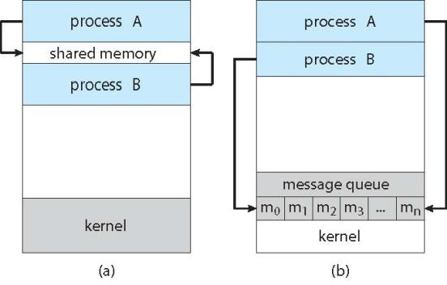

Figure 1.30 Communications models. (a) Message passing. (b) Shared memory.

Recent research on systems with several processing cores indicates that message passing provides better performance than shared memory on such systems. Shared memory suffers from cache coherency issues, which arise because shared data migrate among the several caches. As the number of processing cores on systems increases, it is possible that we will see message passing as the preferred mechanism for IPC.

In the remainder of this section, we explore shared-memory and messagepassing systems in more detail.

**Shared-Memory Systems**

Interprocess communication using shared memory requires communicating processes to establish a region of shared memory. Typically, a shared-memory region resides in the address space of the process creating the shared-memory segment. Other processes that wish to communicate using this shared-memory segment must attach it to their address space. Recall that, normally, the operating system tries to prevent one process from accessing another process’s memory. Shared memory requires that two or more processes agree to remove this restriction. They can then exchange information by reading and writing data in the shared areas. The form of the data and the location are determined by these processes and are not under the operating system’s control. The processes are also responsible for ensuring that they are not writing to the same location simultaneously.

To illustrate the concept of cooperating processes, let’s consider the producer–consumer problem, which is a common paradigm for cooperating processes. A producer process produces information that is consumed by a consumer process. For example, a compiler may produce assembly code that is consumed by an assembler. The assembler, in turn, may produce object modules that are consumed by the loader. The producer–consumer problem also provides a useful metaphor for the client–server paradigm. We generally think of a server as a producer and a client as a consumer. For example, a web server produces (that is, provides) HTML files and images, which are consumed (that is, read) by the client web browser requesting the resource.

One solution to the producer–consumer problem uses shared memory. To allow producer and consumer processes to run concurrently, we must have available a buffer of items that can be filled by the producer and emptied by the consumer. This buffer will reside in a region of memory that is shared by the producer and consumer processes. A producer can produce one item while the consumer is consuming another item. The producer and consumer must be synchronized, so that the consumer does not try to consume an item that has not yet been produced.

Two types of buffers can be used. The unbounded buffer places no practical limit on the size of the buffer. The consumer may have to wait for new items, but the producer can always produce new items. The bounded buffer assumes a fixed buffer size. In this case, the consumer must wait if the buffer is empty, and the producer must wait if the buffer is full.

Let’s look more closely at how the bounded buffer illustrates interprocess communication using shared memory. The following variables reside in a region of memory shared by the producer and consumer processes:

#define BUFFER SIZE 10

typedef struct {

...

}item;

item buffer[BUFFER SIZE];

int in = 0;

int out = 0;

The shared buffer is implemented as a circular array with two logical pointers: in and out. The variable in points to the next free position in the buffer; out points to the first full position in the buffer. The buffer is empty when in == out; the buffer is full when ((in + 1) % BUFFER SIZE) == out.

item next_produced;

while (true) {

/* produce an item in next produced */

while (((in + 1) % BUFFER_SIZE) == out)

; /* do nothing */

buffer[in] = next_produced;

in = (in + 1) % BUFFER_SIZE;

}

Figure 1.31 The producer process using shared memory.

The code for the producer process is shown in Figure 1.31, and the code for the consumer process is shown in Figure 1.32. The producer process has a local variable next produced in which the new item to be produced is stored. The consumer process has a local variable next consumed in which the item to be consumed is stored.

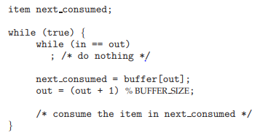

Figure 1.32 The consumer process using shared memory

This scheme allows at most BUFFER SIZE − 1 items in the buffer at the same time. We leave it as an exercise for you to provide a solution in which BUFFER SIZE items can be in the buffer at the same time.

**Message Passing Systems**

We have seen how cooperating processes can communicate in a shared-memory environment. The scheme requires that these processes share a region of memory and that the code for accessing and manipulating the shared memory be written explicitly by the application programmer. Another way to achieve the same effect is for the operating system to provide the means for cooperating processes to communicate with each other via a message-passing facility.

Message passing provides a mechanism to allow processes to communicate and to synchronize their actions without sharing the same address space. It is particularly useful in a distributed environment, where the communicating processes may reside on different computers connected by a network. For example, an Internet chat program could be designed so that chat participants communicate with one another by exchanging messages.

A message-passing facility provides at least two operations:

send(message) receive(message)

Messages sent by a process can be either fixed or variable in size. If only fixed-sized messages can be sent, the system-level implementation is straightforward. This restriction, however, makes the task of programming more difficult. Conversely, variable-sized messages require a more complex system- level implementation, but the programming task becomes simpler. This is a common kind of tradeoff seen throughout operating-system design.

If processes P and Q want to communicate, they must send messages to and receive messages from each other: a communication link must exist between them. This link can be implemented in a variety of ways. We are concerned here not with the link’s physical implementation (such as shared memory, hardware bus, or network but rather with its logical implementation. Here are several methods for logically implementing a link and the send()/receive() operations:

* Direct or indirect communication
* Synchronous or asynchronous communication
* Automatic or explicit buffering

**Naming**

Processes that want to communicate must have a way to refer to each other. They can use either direct or indirect communication.

Under direct communication, each process that wants to communicate must explicitly name the recipient or sender of the communication. In this scheme, the send() and receive() primitives are defined as:

• send(P, message)—Send a message to process P.

• receive(Q, message)—Receive a message from process Q.

A communication link in this scheme has the following properties:

• A link is established automatically between every pair of processes that want to communicate. The processes need to know only each other’s identity to communicate.

• A link is associated with exactly two processes.

• Between each pair of processes, there exists exactly one link.

This scheme exhibits symmetry in addressing; that is, both the sender process and the receiver process must name the other to communicate. A variant of this scheme employs asymmetry in addressing. Here, only the sender names the recipient; the recipient is not required to name the sender. In this scheme, the send() and receive() primitives are defined as follows:

• send(P, message)—Send a message to process P.

• receive(id, message)—Receive a message from any process. The variable id is set to the name of the process with which communication has taken place.

The disadvantage in both of these schemes (symmetric and asymmetric) is the limited modularity of the resulting process definitions. Changing the identifier of a process may necessitate examining all other process definitions. All references to the old identifier must be found, so that they can be modified to the new identifier. In general, any such hard-coding techniques, where identifiers must be explicitly stated, are less desirable than techniques involving indirection, as described next.

With indirect communication, the messages are sent to and received from mailboxes, or ports. A mailbox can be viewed abstractly as an object into which messages can be placed by processes and from which messages can be removed. Each mailbox has a unique identification. For example, POSIX message queues use an integer value to identify a mailbox. A process can communicate with another process via a number of different mailboxes, but two processes can communicate only if they have a shared mailbox. The send() and receive() primitives are defined as follows:

• send(A, message)—Send a message to mailbox A.

• receive(A, message)—Receive a message from mailbox A.

In this scheme, a communication link has the following properties:

• A link is established between a pair of processes only if both members of the pair have a shared mailbox.

• A link may be associated with more than two processes.

• Between each pair of communicating processes, a number of different links may exist, with each link corresponding to one mailbox.

Now suppose that processes P1, P2, and P3 all share mailbox A. Process P1 sends a message to A, while both P2 and P3 execute a receive() from A. Which process will receive the message sent by P1? The answer depends on which of the following methods we choose:

• Allow a link to be associated with two processes at most.

• Allow at most one process at a time to execute a receive() operation.

• Allow the system to select arbitrarily which process will receive the message (that is, either P2 or P3, but not both, will receive the message). The system may define an algorithm for selecting which process will receive the message (for example, round robin, where processes take turns receiving messages). The system may identify the receiver to the sender.

A mailbox may be owned either by a process or by the operating system. If the mailbox is owned by a process (that is, the mailbox is part of the address space of the process), then we distinguish between the owner (which can only receive messages through this mailbox) and the user (which can only send messages to the mailbox). Since each mailbox has a unique owner, there can be no confusion about which process should receive a message sent to this mailbox. When a process that owns a mailbox terminates, the mailbox disappears. Any process that subsequently sends a message to this mailbox must be notified that the mailbox no longer exists.

In contrast, a mailbox that is owned by the operating system has an existence of its own. It is independent and is not attached to any particular process. The operating system then must provide a mechanism that allows a process to do the following:

• Create a new mailbox.

• Send and receive messages through the mailbox.

• Delete a mailbox.

The process that creates a new mailbox is that mailbox’s owner by default. Initially, the owner is the only process that can receive messages through this mailbox. However, the ownership and receiving privilege may be passed to other processes through appropriate system calls. Of course, this provision could result in multiple receivers for each mailbox.

**Synchronization**

Communication between processes takes place through calls to send() and receive() primitives. There are different design options for implementing each primitive. Message passing may be either blocking or nonblocking— also known as synchronous and asynchronous. (Throughout this text, you will encounter the concepts of synchronous and asynchronous behavior in relation to various operating-system algorithms.)

• Blocking send. The sending process is blocked until the message is received by the receiving process or by the mailbox.

• Nonblocking send. The sending process sends the message and resumes operation.

• Blocking receive. The receiver blocks until a message is available.

• Nonblocking receive. The receiver retrieves either a valid message or a null.

**Buffering**

Whether communication is direct or indirect, messages exchanged by communicating processes reside in a temporary queue. Basically, such queues can be implemented in three ways:

• Zero capacity. The queue has a maximum length of zero; thus, the link cannot have any messages waiting in it. In this case, the sender must block until the recipient receives the message.

• Bounded capacity. The queue has finite length n; thus, at most n messages can reside in it. If the queue is not full when a new message is sent, the message is placed in the queue (either the message is copied or a pointer to the message is kept), and the sender can continue execution without waiting. The link’s capacity is finite, however. If the link is full, the sender must block until space is available in the queue.

• Unbounded capacity. The queue’s length is potentially infinite; thus, any number of messages can wait in it. The sender never blocks.

The zero-capacity case is sometimes referred to as a message system with no buffering. The other cases are referred to as systems with automatic buffering.

**Examples of IPC Systems**

In this section, we explore three different IPC systems. We first cover the POSIX API for shared memory and then discuss message passing in the Mach operating system. We conclude with Windows, which interestingly uses shared memory as a mechanism for providing certain types of message passing.

**An Example: POSIX Shared Memory**

Several IPC mechanisms are available for POSIX systems, including shared memory and message passing. Here, we explore the POSIX API for shared memory.

POSIX shared memory is organized using memory-mapped files, which associate the region of shared memory with a file. A process must first create

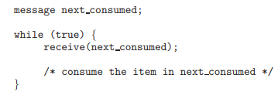

Figure 1.32 The consumer process using message passing.

a shared-memory object using the shm open() system call, as follows:

shm fd = shm open(name, O CREAT | O RDRW, 0666);

The first parameter specifies the name of the shared-memory object. Processes that wish to access this shared memory must refer to the object by this name. The subsequent parameters specify that the shared-memory object is to be created if it does not yet exist (O CREAT) and that the object is open for reading and writing (O RDRW). The last parameter establishes the directory permissions of the shared-memory object. A successful call to shm open() returns an integer file descriptor for the shared-memory object.

Once the object is established, the ftruncate() function is used to configure the size of the object in bytes. The call sets the size of the object to 4,096 bytes.

ftruncate(shm fd, 4096);

Finally, the mmap() function establishes a memory-mapped file containing the shared-memory object. It also returns a pointer to the memory-mapped file that is used for accessing the shared-memory object.

The programs shown in Figure 1.33 and 1.34 use the producer–consumer model in implementing shared memory. The producer establishes a sharedmemory object and writes to shared memory, and the consumer reads from shared memory.

The producer, shown in Figure 1.33, creates a shared-memory object named OS and writes the infamous string "Hello World!" to shared memory. The program memory-maps a shared-memory object of the specified size and allows writing to the object. (Obviously, only writing is necessary for the producer.) The flag MAP SHARED specifies that changes to the shared-memory object will be visible to all processes sharing the object. Notice that we write to the shared-memory object by calling the sprintf() function and writing the formatted string to the pointer ptr. After each write, we must increment the pointer by the number of bytes written.

The consumer process, shown in Figure 1.34, reads and outputs the contents of the shared memory. The consumer also invokes the shm unlink() function, which removes the shared-memory segment after the consumer has accessed it. We provide further exercises using the POSIX shared-memory API in the programming exercises at the end of this chapter.

**An Example: Mach**

As an example of message passing, we next consider the Mach operating system. The Mach kernel supports the creation and destruction of multiple tasks, which are similar to processes but have multiple threads of control and fewer associated resources. Most communication in Mach— including all intertask information—is carried out by messages. Messages are sent to and received from mailboxes, called ports in Mach.

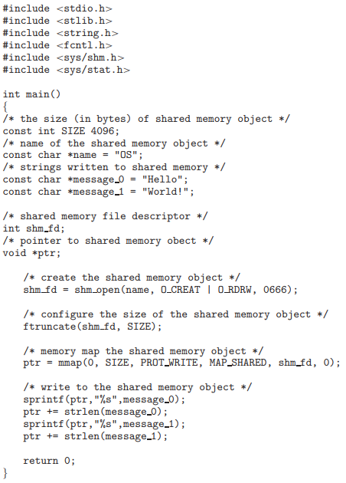

Figure 1.33 Producer process illustrating POSIX shared-memory API.

Even system calls are made by messages. When a task is created, two special mailboxes—the Kernel mailbox and the Notify mailbox—are also created. The kernel uses the Kernel mailbox to communicate with the task and sends notification of event occurrences to the Notify port. Only three system calls are needed for message transfer. The msg send() call sends a message to a mailbox. A message is received via msg receive(). Remote procedure calls (RPCs) are executed via msg rpc(), which sends a message and waits for exactly one return message from the sender. In this way, the RPC models a typical subroutine procedure call but can work between systems—hence the term remote.

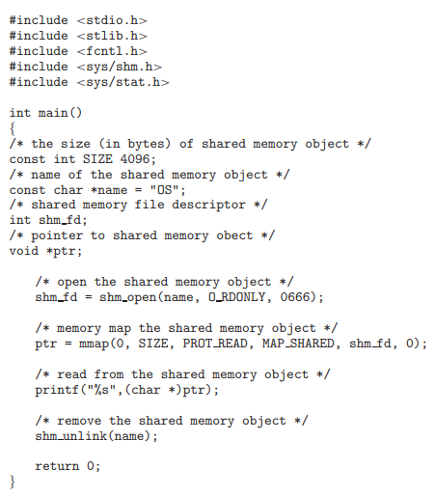

Figure 1.34 Consumer process illustrating POSIX shared-memory API

The port allocate() system call creates a new mailbox and allocates space for its queue of messages. The maximum size of the message queue defaults to eight messages. The task that creates the mailbox is that mailbox’s owner. The owner is also allowed to receive from the mailbox. Only one task at a time can either own or receive from a mailbox, but these rights can be sent to other tasks.

The mailbox’s message queue is initially empty. As messages are sent to the mailbox, the messages are copied into the mailbox. All messages have the same priority. Mach guarantees that multiple messages from the same sender are queued in first-in, first-out (FIFO) order but does not guarantee an absolute ordering. For instance, messages from two senders may be queued in any order.

The messages themselves consist of a fixed-length header followed by a variable-length data portion. The header indicates the length of the message and includes two mailbox names. One mailbox name specifies the mailbox to which the message is being sent. Commonly, the sending thread expects a reply, so the mailbox name of the sender is passed on to the receiving task, which can use it as a “return address.”

The variable part of a message is a list of typed data items. Each entry in the list has a type, size, and value. The type of the objects specified in the message is important, since objects defined by the operating system—such as ownership or receive access rights, task states, and memory segments—may be sent in messages.

The send and receive operations themselves are flexible. For instance, when a message is sent to a mailbox, the mailbox may be full. If the mailbox is not full, the message is copied to the mailbox, and the sending thread continues. If the mailbox is full, the sending thread has four options:

1. Wait indefinitely until there is room in the mailbox.

2. Wait at most n milliseconds.

3. Do not wait at all but rather return immediately.

4. Temporarily cache a message. Here, a message is given to the operating system to keep, even though the mailbox to which that message is being sent is full. When the message can be put in the mailbox, a message is sent back to the sender. Only one message to a full mailbox can be pending at any time for a given sending thread.

The final option is meant for server tasks, such as a line-printer driver. After finishing a request, such tasks may need to send a one-time reply to the task that requested service, but they must also continue with other service requests, even if the reply mailbox for a client is full.

The receive operation must specify the mailbox or mailbox set from which a message is to be received. A mailbox set is a collection of mailboxes, as declared by the task, which can be grouped together and treated as one mailbox for the purposes of the task. Threads in a task can receive only from a mailbox or mailbox set for which the task has receive access. A port status() system call returns the number of messages in a given mailbox. The receive operation attempts to receive from (1) any mailbox in a mailbox set or (2) a specific (named) mailbox. If no message is waiting to be received, the receiving thread can either wait at most n milliseconds or not wait at all.

The Mach system was especially designed for distributed systems but Mach was shown to be suitable for systems with fewer processing cores, as evidenced by its inclusion in the Mac OS X system. The major problem with message systems has generally been poor performance caused by double copying of messages: the message is copied first from the sender to the mailbox and then from the mailbox to the receiver. The Mach message system attempts to avoid double-copy operations by using virtual-memory-management techniques. Essentially, Mach maps the address space containing the sender’s message into the receiver’s address space. The message itself is never actually copied. This message-management technique provides a large performance boost but works for only intrasystem messages.

**An Example: Windows**

The Windows operating system is an example of modern design that employs modularity to increase functionality and decrease the time needed to implement new features. Windows provides support for multiple operating environments, or subsystems. Application programs communicate with these subsystems via a message-passing mechanism. Thus, application programs can be considered clients of a subsystem server.

The message-passing facility in Windows is called the advanced local procedure call (ALPC) facility. It is used for communication between two processes on the same machine. It is similar to the standard remote procedure call (RPC) mechanism that is widely used, but it is optimized for and specific to Windows. Like Mach, Windows uses a port object to establish and maintain a connection between two processes. Windows uses two types of ports: connection ports and communication ports.

Server processes publish connection-port objects that are visible to all processes. When a client wants services from a subsystem, it opens a handle to the server’s connection-port object and sends a connection request to that port. The server then creates a channel and returns a handle to the client. The channel consists of a pair of private communication ports: one for client—server messages, the other for server—client messages. Additionally, communication channels support a callback mechanism that allows the client and server to accept requests when they would normally be expecting a reply.

When an ALPC channel is created, one of three message-passing techniques is chosen:

1. For small messages (up to 256 bytes), the port’s message queue is used as intermediate storage, and the messages are copied from one process to the other.

2. Larger messages must be passed through a section object, which is a region of shared memory associated with the channel.

3. When the amount of data is too large to fit into a section object, an API is available that allows server processes to read and write directly into the address space of a client.

The client has to decide when it sets up the channel whether it will need to send a large message. If the client determines that it does want to send large messages, it asks for a section object to be created. Similarly, if the server decides that replies will be large, it creates a section object. So that the section object can be used, a small message is sent that contains a pointer and size information about the section object. This method is more complicated than the first method listed above, but it avoids data copying. The structure of advanced local procedure calls in Windows is shown in Figure 1.35.

It is important to note that the ALPC facility in Windows is not part of the Windows API and hence is not visible to the application programmer. Rather, applications using the Windows API invoke standard remote procedure calls. When the RPC is being invoked on a process on the same system, the RPC is handled indirectly through an ALPC. procedure call. Additionally, many kernel services use ALPC to communicate with client processes.

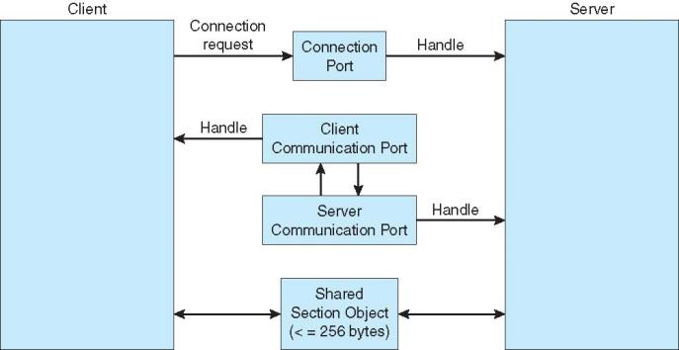

Figure 1.35 Advanced local procedure calls in Windows.

**Communication in Client–Server Systems**

We have described how processes can communicate using shared memory and message passing. These techniques can be used for communication in client–server systems as well. In this section, we explore three other strategies for communication in client–server systems: sockets, remote procedure calls (RPCs), and pipes.

**Sockets**

A socket is defined as an endpoint for communication. A pair of processes communicating over a network employs a pair of sockets—one for each process. A socket is identified by an IP address concatenated with a port number. In general, sockets use a client–server architecture. The server waits for incoming client requests by listening to a specified port. Once a request is received, the server accepts a connection from the client socket to complete the connection. Servers implementing specific services (such as telnet, FTP, and HTTP) listen to well-known ports (a telnet server listens to port 23; an FTP server listens to port 21; and a web, or HTTP, server listens to port 80). All ports below 1024 are considered well known; we can use them to implement standard services.

**Remote Procedure Calls**

One of the most common forms of remote service is the RPC paradig,. The RPC was designed as a way to abstract the procedure-call mechanism for use between systems with network connections. It is similar in many respects to the IPC mechanism and it is usually built on top of such a system. Here, however, because we are dealing with an environment in which the processes are executing on separate systems, we must use a message-based communication scheme to provide remote service.

In contrast to IPC messages, the messages exchanged in RPC communication are well structured and are thus no longer just packets of data. Each message is addressed to an RPC daemon listening to a port on the remote system, and each contains an identifier specifying the function to execute and the parameters to pass to that function. The function is then executed as requested, and any output is sent back to the requester in a separate message.